1. Calculate the volume:  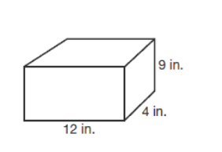 | 2. Calculate the volume:  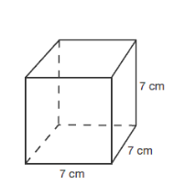
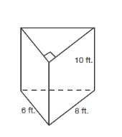  3. Calculate the volume: | 4. Calculate the volume:  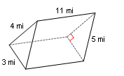
5. Calculate the volume:  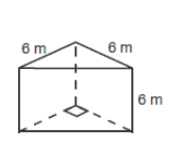 | 6. A rectangular vegetable garden has dimensions 12 feet wide by 16 feet long by 3 ft deep. If I want to fill it with soil, how many cubic feet of soil do I need?
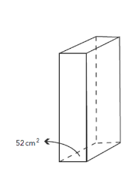  7. In the figure below, the area of the base is 52 cm² and the volume is 468 cm³. What is the height of the prism? | 8. A rectangular vegetable garden has dimensions 12 feet wide by 8 feet long by 3 ft deep. I am going to fill it with soil that costs $0.75 per cubic foot. How much will the soil cost, assuming 6.5% sales tax?
1. Calculate the volume: | 2. Calculate the volume:
3. Calculate the volume: | 4. Calculate the volume:
5. Calculate the volume: | 6. A rectangular vegetable garden has dimensions 12 feet wide by 16 feet long by 3 ft deep. If I want to fill it with soil, how many cubic feet of soil do I need?
7. In the figure below, the area of the base is 52 cm² and the volume is 468 cm³. What is the height of the prism? | 8. A rectangular vegetable garden has dimensions 12 feet wide by 8 feet long by 3 ft deep. I am going to fill it with soil that costs $0.75 per cubic foot. How much will the soil cost, assuming 6.5% sales tax?

