ANSWER YOU’RE LOOKING FOR:
17

LETTER:R
Mrs. Harris has 5 blue, 8 red, 3 green, and 7 yellow candies in a bag. If Mrs. Harris randomly selects a candy, what is the probability she will select a yellow or blue candy?

ANSWER YOU’RE LOOKING FOR:
$$\frac{12}{23}$$
LETTER:E
Janet will spin the two spinners below at the same time.
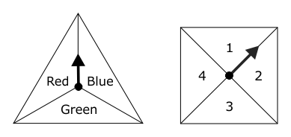
What is the probability the spinners will land on Red and on 3?

ANSWER YOUR LOOKING FOR:
$$\frac{1}{12}$$
LETTER:U
PROBLEM:
What is the probability of landing in an unshaded region on Spinner 1 and on the number 4 on Spinner 2?
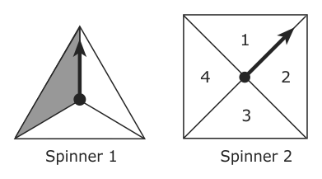

ANSWER YOUR LOOKING FOR:
$$\frac{1}{6}$$
LETTER:L
PROBLEM:
Jeremy will toss a coin 3 times. What is the probability Jeremy’s coin will land on heads for each toss?

ANSWER YOUR LOOKING FOR:
$$\frac{1}{8}$$
LETTER:A
PROBLEM:
Mary is making a necklace by alternating red, yellow, and green beads. In a bowl, she has 20 red beads, 20 yellow beads, and 20 green beads. If Mary needs a red bead, what is the probability of her picking one randomly?

ANSWER YOUR LOOKING FOR:
$$\frac{1}{3}$$
LETTER:T
PROBLEM:

Kelly will roll a number cube labeled 1 to 6. What is the probability Kelly will roll a number greater than 3?

ANSWER YOUR LOOKING FOR:
$$\frac{1}{2}$$
LETTER:I
PROBLEM:

There are 13 boys and 12 girls in Mrs. Allen’s class. What is the probability that a randomly selected student is a girl?

ANSWER YOUR LOOKING FOR:
$$\frac{12}{25}$$
LETTER:O
PROBLEM:

David has a red and a blue number cube each labeled 1 to 6. He will roll both number cubes at the same time. What is the probability David will roll a 6 on the red cube and an even number on the blue cube?

ANSWER YOUR LOOKING FOR:
$$\frac{1}{12}$$
LETTER:N
PROBLEM:
In a game, the probability of winning is 1 out of 5. How many times could Lisa expect to win if she plays the game 85 times?

