- Gemini went to the mall and wants to buy a shirt for $35. Tax is 7%. What is his total including tax?
Original price:
Tax in dollars:
_______________+____________________

Final price=
Original price:
Percent as decimal:
__________________x_________________________

Tax in dollars =

- Chris wants to spend his allowance on a scooter. The scooter costs $65. Chris jumped for joy! He has to pay 6.5% sales tax on his scooter. What will Chris pay for his scooter including tax?
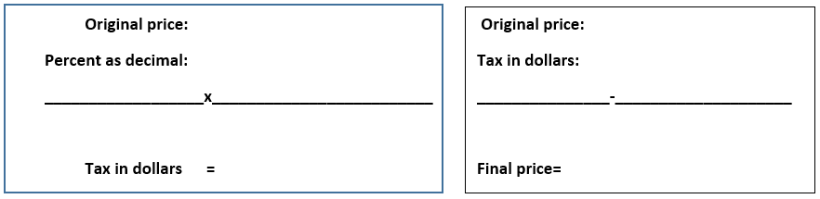
- Ms. G wants to buy 12 used Ipads for $110 each on Ebay. How much will Ms. G pay for her total purchase if the sales tax is 7.25%?
- Ms. Stout wants to buy an Iphone 6 for $199. She has to pay 8.5% tax. What does she end up paying all together?

