Tic-Tac-Math Solving Inequalities

Rules and Play
- Two Players take turns selecting and solving problems.

- If a player solves a problem correctly, he/she marks the cell with a symbol such as X, or O, initials, etc. If a player answers incorrectly, no mark is allowed and play passes to the next player.

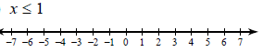 | -6n + 12 ≥ 48 | 0.11x + 1.5 <2.49
2y + 15 ≥ 17 | -4x + 7 < 19 | 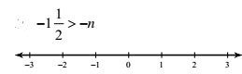
$\frac{n}{-7}$> 4 | 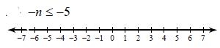 | 9n – 8n + 16 < 45
- Players receive 25 points for each tic-tac-toe (3 marks in a row, column, or diagonal).

- The game ends when the board is filled. The player with the most points wins.

