Name: Date:
Area and Circumference Practice Block:
1. A flower pot as a circumference of 35 inches. What is the approximate length of the radius of the flower pot?

2. The diameter of a circle on a coordinate plan has endpoints at (2,3) and (2,8). What is the approximate area of the circle?

3. The radius of the larger circle is 5 meters. The radius of the smaller circle is 2.5 meters. What is the approximate area of the shaded region of the larger circle?

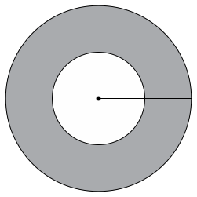
4. A clock face has a diameter of 14 inches. What is the area of the face of the clock in square inches?

5. Mario ordered a pizza that had a diameter of 14in. What is the approximate area of the pizza?

6. A circle has an area of $36π$ square centimeters. What is the circumference of the circle in centimeters?

7. A circle has a circumference of about 54in. What is the approximate measure of the diameter?

8. A circle has an area of approximately 615 square millimeters. What is the diameter of the circle to the nearest millimeter?

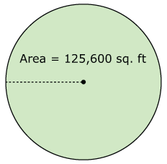

9. Denise wants to irrigate a circular field. She will irrigate the field with a straight pipe. The pipe will rotate about the center of the field. She knows the circular field has an area of 125,600 square feet. What is the length of the irrigation pipe?

10. Josh is painting a circle on a local softball field. The circle has a diameter of 2.5 feet. What is the approximate circumference of the circle?

11. John painted a circle on the athletic field with a radius of 25ft. What is the approximate circumference of John’s circle?

12. Paul bought a circular rug for his living room. The rug has a diameter of 11 feet. About how much of Paul’s living room will be covered with the rug?

13. A circular pool has a radius of 6ft. What is the approximate circumference of the pool?

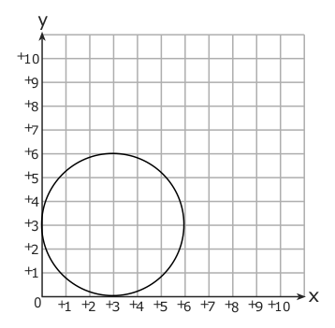
14. What is the approximate area of the circle below?

15. A circular mirror has a circumference of 85 inches. What is the diameter of the mirror?

16. Mrs. Harper made a pizza with a 9-inch radius. What is the approximate circumference of the pizza?

17. A circle has a radius of 6 feet. What is the approximate circumference?

18. The radius of a bicycle wheel is 12in. What is the approximate circumference of the wheel?

19. Determine the circumference and area for each of the following circles:
a. radius = 7ft b. diameter = 16in

c. diameter = 12cm d. radius = 20mm.

