In the figure below, ∠OQP is a right angle.
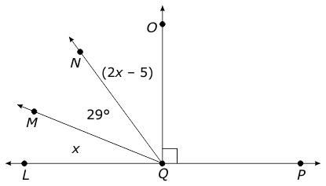
What is the measurement of ∠LQM?

In the figure below, ∠PQT measures (2x + 12)°.
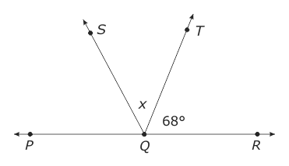
What is the measure of ∠PQS?

In the figure below, what is the measure of ∠x?
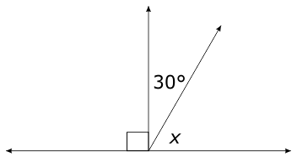

In the figure below, ∠EFH and ∠HFG are supplementary.
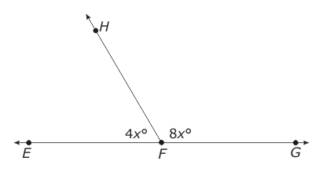
What is the measure of ∠HFG?

In the figure below, points P, Q, and R are on a straight line. Angle RQV and ∠VQT are complementary.
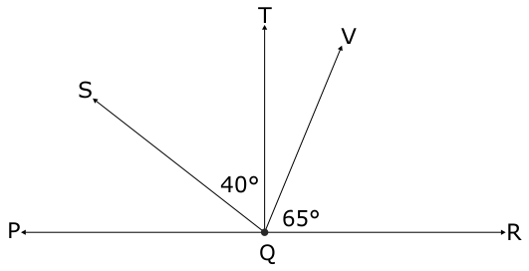
What is the measure of ∠PQS?

In the figure below, ∠EFH and ∠HFG are supplementary.
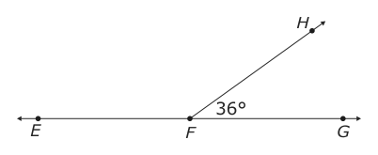
What is the measure of ∠EFH?

In the figure below, ∠LMR measures 120°.
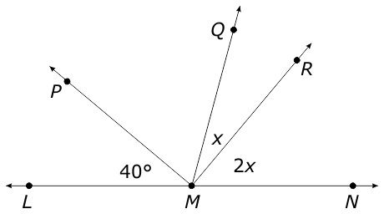
What is the measure of ∠PMQ?

In the figure below, line JM is perpendicular to ray LP.
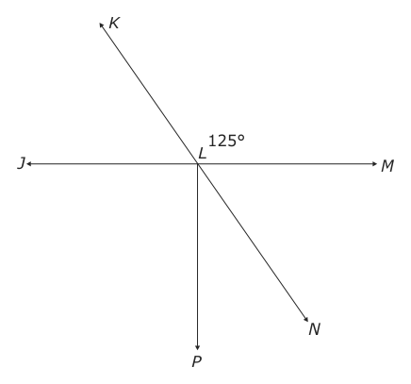
What is the measure of angle NLP?
In the figure below, all lines intersect at point M.
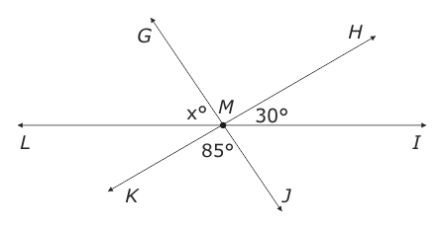
What is the measure of ∠GML?

