We have already dealt with the simple volume formulas. Let’s see if you remember them!
Find the volumes of…

3ft
2ft
13ft
3in
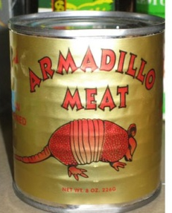
1. 2.
5in

FORMULA:
SUBSTITUTE:
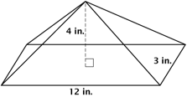
ANSWER:
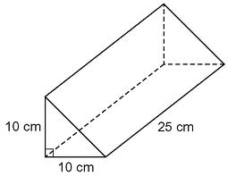
3. 4.

FORMULA: l · w · h
3
SUBSTITUTE:
ANSWER:
FORMULA: b · h · l
2
SUBSTITUTE:
ANSWER:
Irregularity is the Way to Go!
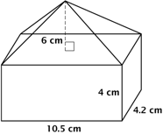
Let’s face it…almost all of the 3-D figures in the world are not in a perfect shape (except for Mr. Z). So what good is it finding volumes of those shapes? Let’s look at irregular shapes!

Think Tank: If the length of the figure was doubled and the width was halved, what would happen to the volume?

You are trying to mysteriously uncover what you are getting for the holiday season by determining the volume. You were able to measure almost everything before your mom comes in! Luckily, you found the following measurements, and you also (somehow) know that the volume is 3,240$cm^{3}$. What is the height of the base?
On Your Own:
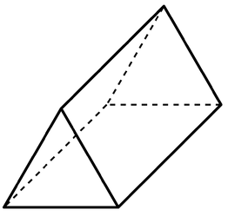
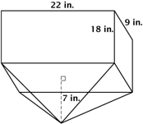

30cm
18cm

