WARM UP/  REVIEW | 1. Simplify: 7(8x – 6y + 9)  2. Identify the constant of proportionality (unit rate) using the table below. Give the rate in feet per second.  Seconds Feet  5 120  15 360  20 480  3. Jonah had 120 stickers in his collection. If his collection grows by 30%, how many stickers are in his collection?
VOCAB | Probability:  Outcome:  Experiment:
Notes | - Probability is usually represented as a fraction or a percent.  - To estimate experimental probability we use proportions.  - The closer the fraction is to 1, the greater the probability the event will occur.  - The sum of all possible outcomes is one.
PRACTICE  Do this AFTER LESSON ACTIVITY!!!!!!! | 1. A bag contains 5 blue sticks, 4 red sticks, and 3 orange sticks and you ask a friend to pick one without looking. What is the probability that the stick will be blue?  2. You ask a friend to think of a number from two to eleven. What is the probability that his number will be 5?  3. You think of a number from the first thirty negative integers. What is the probability that the integer chosen will be divisible by 5?  4. Mary is making a necklace by alternating red, yellow, and green beads. In a bowl, she has 20 red beads, 20 yellow beads, and 20 green beads. If Mary needs a red bead, what is the probability of her picking one randomly?  5. Kelly will roll a number cube labeled 1 to 6. What is the probability Kelly will roll a number greater than 3?
Ticket out | 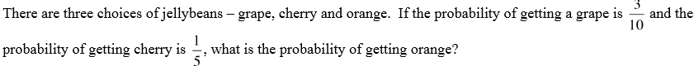
WARM UP/  REVIEW | 1. Simplify: 7(8x – 6y + 9)  2. Identify the constant of proportionality (unit rate) using the table below. Give the rate in feet per second.  Seconds Feet  5 120  15 360  20 480  3. Jonah had 120 stickers in his collection. If his collection grows by 30%, how many stickers are in his collection?
VOCAB | Probability:  Outcome:  Experiment:
Notes | - Probability is usually represented as a fraction or a percent.  - To estimate experimental probability we use proportions.  - The closer the fraction is to 1, the greater the probability the event will occur.  - The sum of all possible outcomes is one.
PRACTICE  Do this AFTER LESSON ACTIVITY!!!!!!! | 1. A bag contains 5 blue sticks, 4 red sticks, and 3 orange sticks and you ask a friend to pick one without looking. What is the probability that the stick will be blue?  2. You ask a friend to think of a number from two to eleven. What is the probability that his number will be 5?  3. You think of a number from the first thirty negative integers. What is the probability that the integer chosen will be divisible by 5?  4. Mary is making a necklace by alternating red, yellow, and green beads. In a bowl, she has 20 red beads, 20 yellow beads, and 20 green beads. If Mary needs a red bead, what is the probability of her picking one randomly?  5. Kelly will roll a number cube labeled 1 to 6. What is the probability Kelly will roll a number greater than 3?
Ticket out

