WARM UP/  REVIEW | 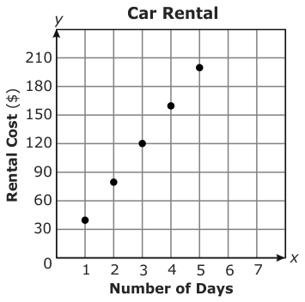  1. The graph to the right shows the cost to rent a car from a company for different numbers of days.  What is the cost per day to rent a car?  2. What is the value of x in the equation $5x+5=8\frac{3}{4}?$  3. The circumference of a circle is 19 in. What is the approximate diameter of the circle?
VOCAB | Right Angle: Acute Angle:  Obtuse Angle: Straight Angle:  Vertex: Congruent Angles:
NOTES | a) Complementary Angles:  b) Supplementary Angles:  c) Adjacent Angles:  d) Vertical Angles:
PRACTICE  Do this AFTER LESSON ACTIVITY!!!!!!! | 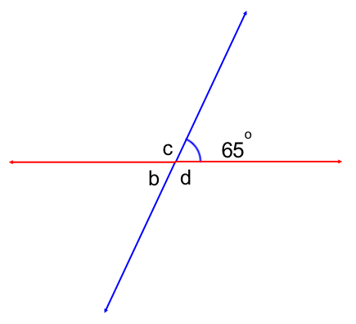  1. Using what you know about vertical angles, find the measure of all the missing angles in each figure below. You must be able to explain why.  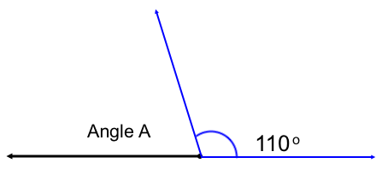  2. What is the complement of 680? Supplement?  3. Angle M has a measure of 46⁰ and Angle N has a measure of 34⁰. Are these two angles congruent? Why or why not?  4. Parallel lines m and n are cut by a transversal l. If the measure of angle 5 is 68⁰ determine the measures of the remaining angles. You must be able to explain why.  Angle Measurement Reason  $$∠1$$  $$∠2$$  $$∠3$$  $$∠4$$  $$∠6$$  $$∠7$$  $$∠8$$  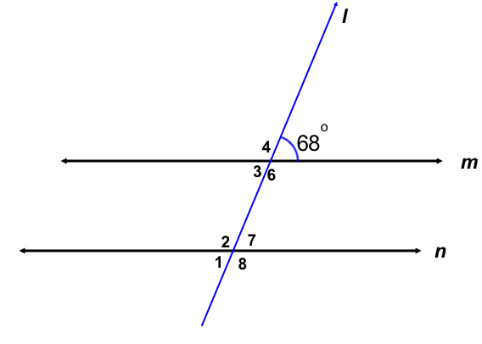
Ticket out
WARM UP/  REVIEW | 1. The graph to the right shows the cost to rent a car from a company for different numbers of days.  What is the cost per day to rent a car?  2. What is the value of x in the equation $5x+5=8\frac{3}{4}?$  3. The circumference of a circle is 19 in. What is the approximate diameter of the circle?
VOCAB | Right Angle: Acute Angle:  Obtuse Angle: Straight Angle:  Vertex: Congruent Angles:
NOTES | a) Complementary Angles:  b) Supplementary Angles:  c) Adjacent Angles:  d) Vertical Angles:
PRACTICE  Do this AFTER LESSON ACTIVITY!!!!!!! | 1. Using what you know about vertical angles, find the measure of all the missing angles in each figure below. You must be able to explain why.  2. What is the complement of 680? Supplement?  3. Angle M has a measure of 46⁰ and Angle N has a measure of 34⁰. Are these two angles congruent? Why or why not?  4. Parallel lines m and n are cut by a transversal l. If the measure of angle 5 is 68⁰ determine the measures of the remaining angles. You must be able to explain why.  Angle Measurement Reason  $$∠1$$  $$∠2$$  $$∠3$$  $$∠4$$  $$∠6$$  $$∠7$$  $$∠8$$
Ticket out

